**ASSIGNMENT-1**

21MAT117  
MATHEMATICS FOR INTELLIGENT SYSTEMS-II

Professor  
Dr. Nimal Madhu

Submitted BY: -

Vikhyat Bansal [CB.EN.U4AIE21076]



EXERCISE  
For each of the following situations, state the probability rule or rules that you would use and apply it or them. Write a sentence explaining how the situation illustrates the use of the probability rules.

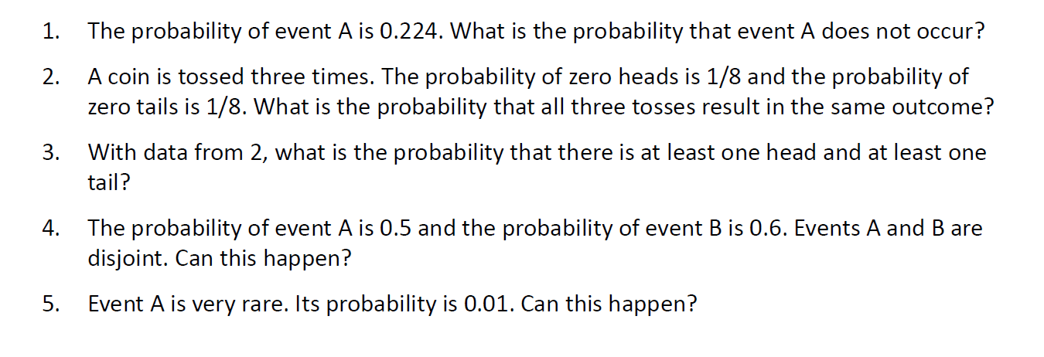

Ans.

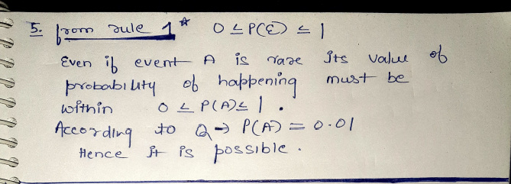

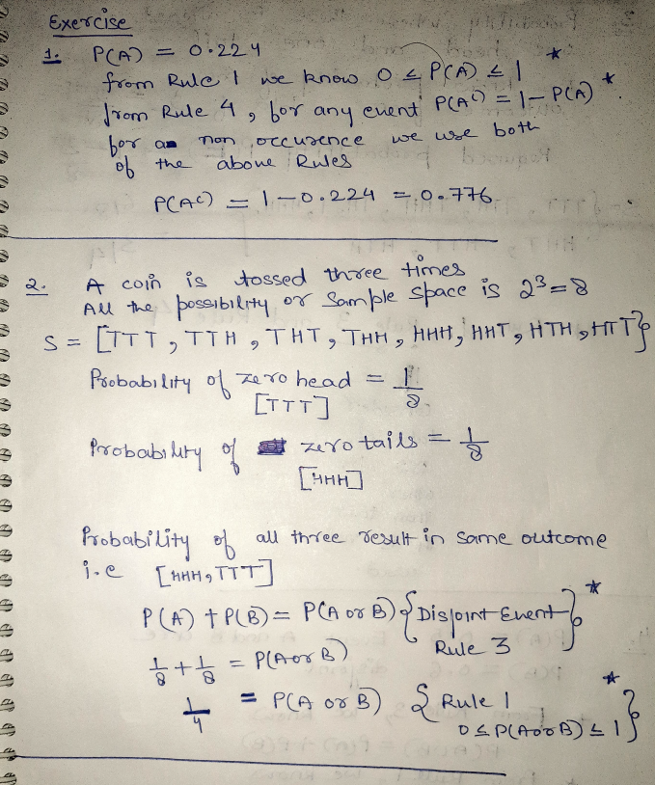

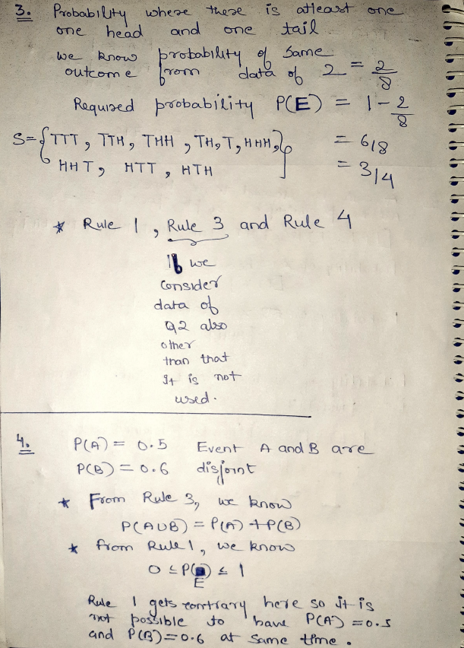

A).

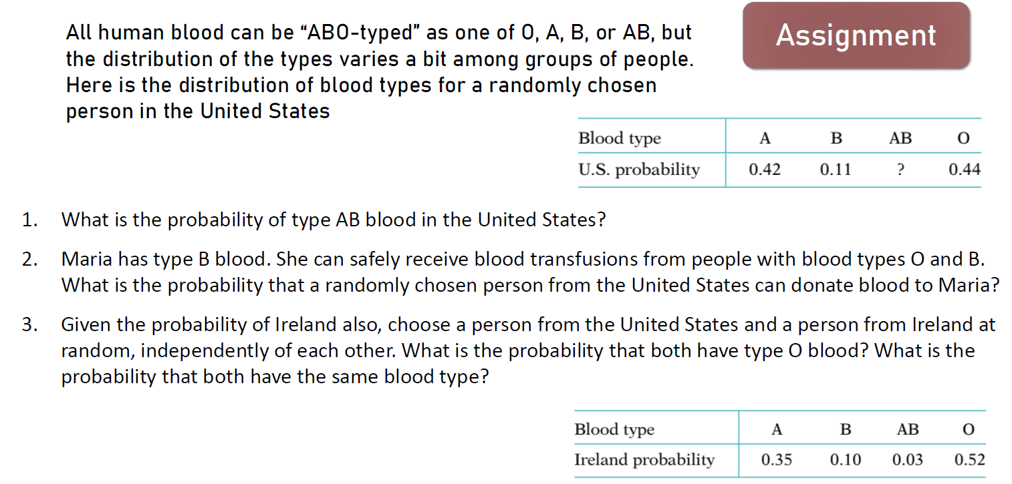

1.)

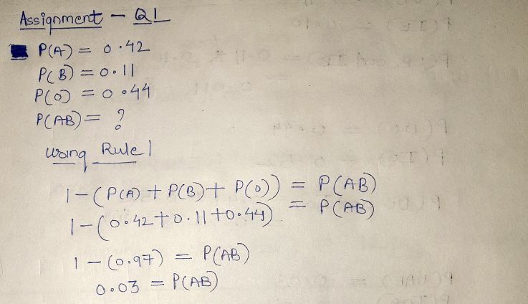

2.)

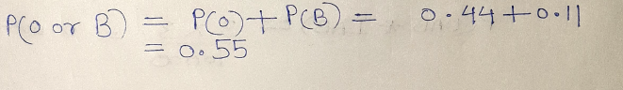

3.)

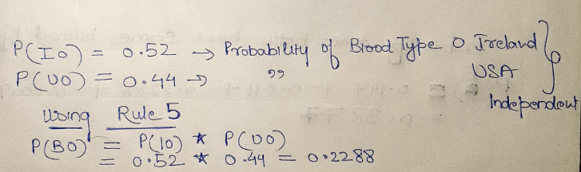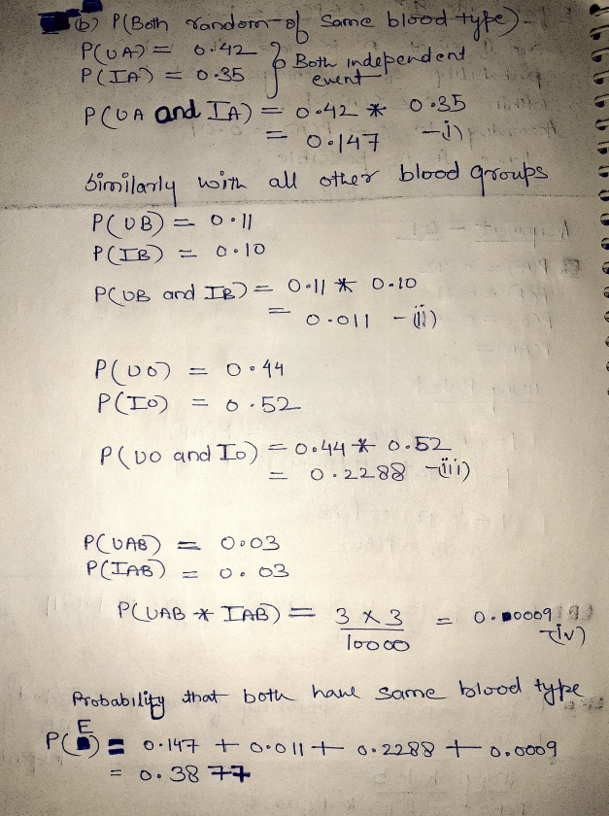

B.) 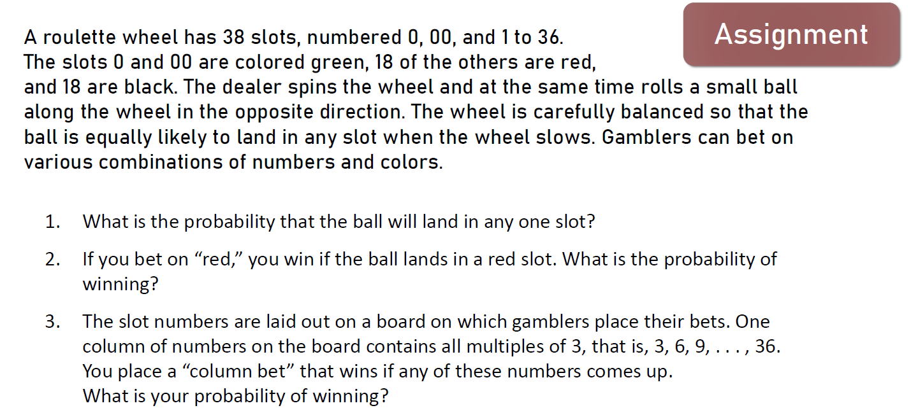

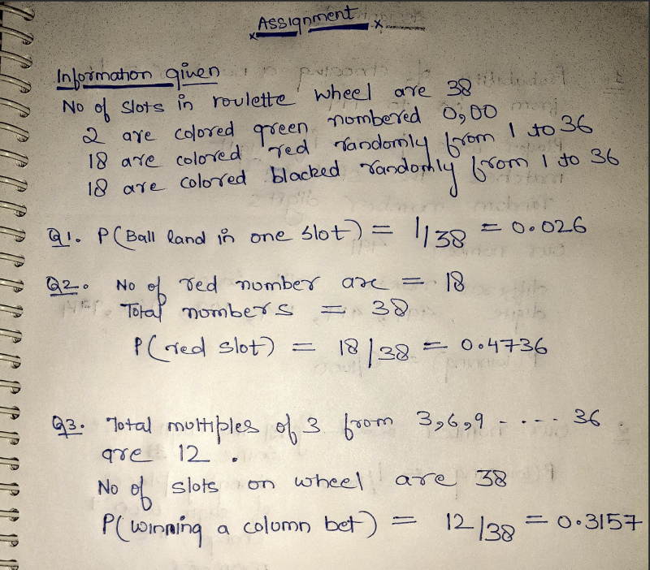

C.)

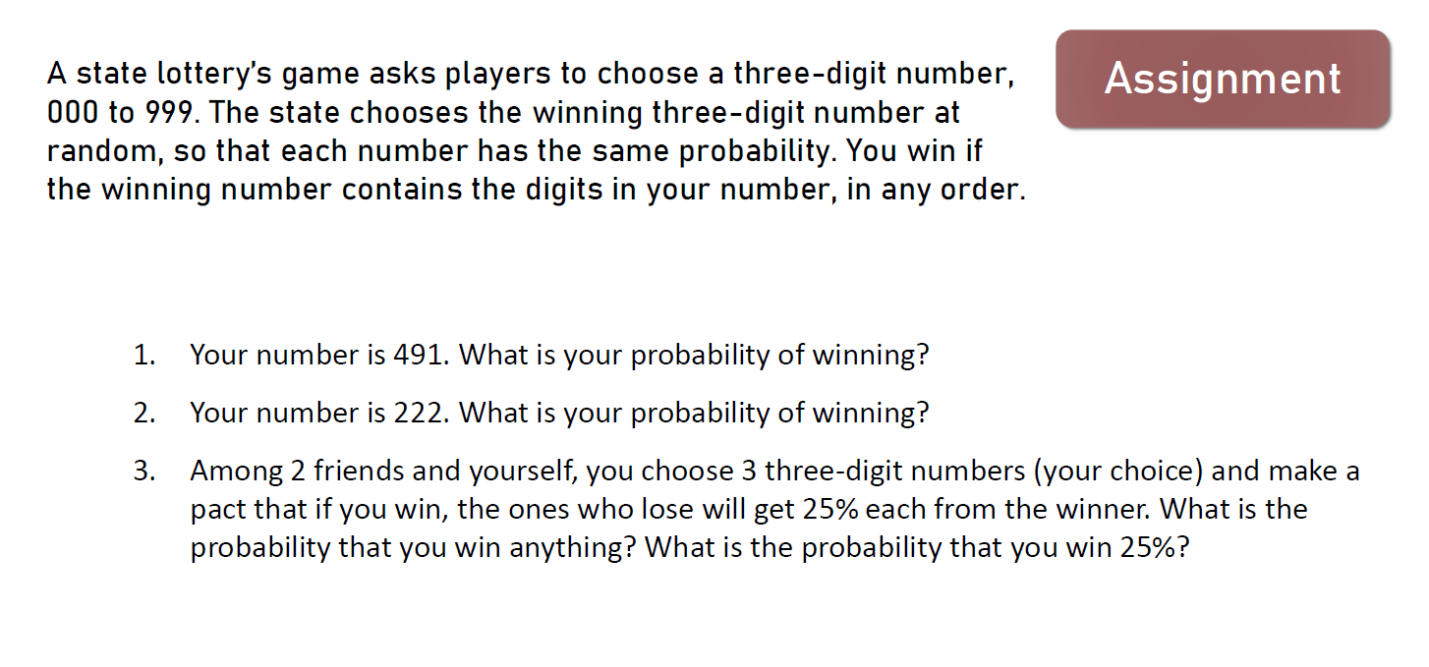

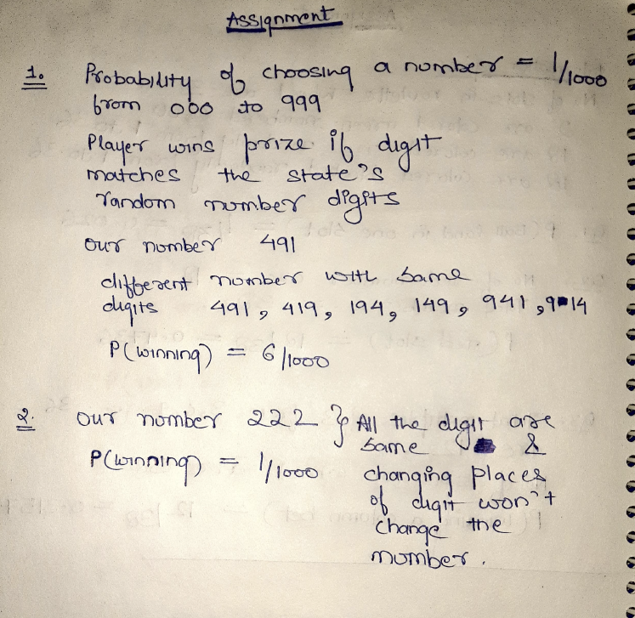

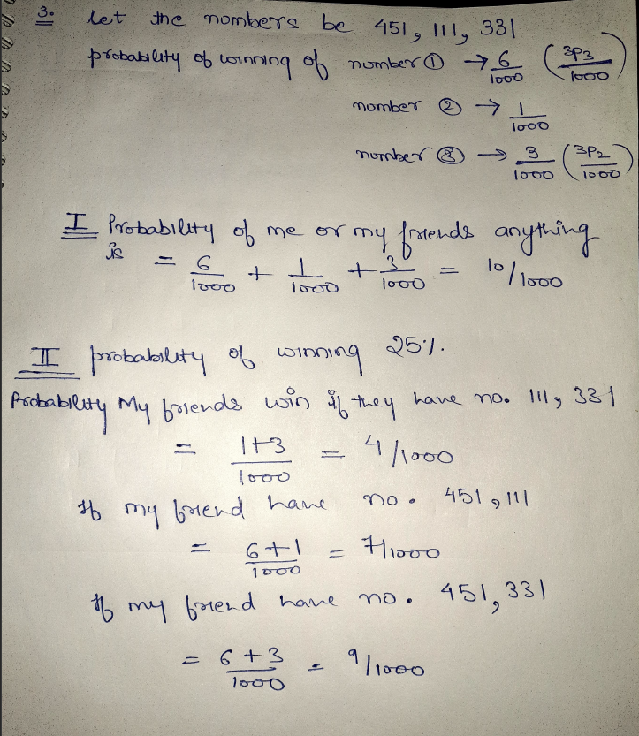

**THANK YOU**